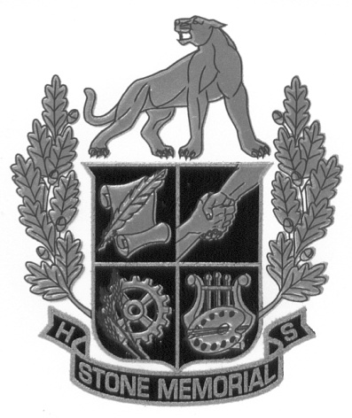 | Stone Memorial High School  2800 Cook Road ∙ Crossville, TN 38571  Telephone (931) 484-5767  Kelly J. Smith  Principal

